Introduction to Human Interaction Robotics

WORKSHEET #1

1. Describe the function for each of the listed callouts in the table below:

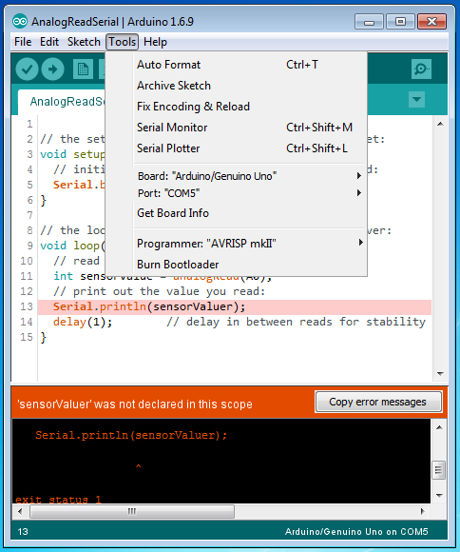

(d)

(c)

(a)

(b)

(f)

(g)

(e)

|  |  |
| --- | --- |
| **(a)** |  |
| **(b)** |  |
| **(c)** |  |
| **(d)** |  |
| **(e)** |  |
| **(f)** |  |
| **(g)** |  |

1. Define the following concepts regarding robotics:

|  |  |
| --- | --- |
| **Teleoperation** |  |
| **Power Augmentation** |  |
| **Prosthetics** |  |

Embedded Programming, Sensors and Actuators

WORKSHEET #2

1. Convert the voltage value on the analog input pin to the value measured by Arduino:

|  |  |
| --- | --- |
| **Voltage [V]** | **Serial Measurement** |
| 0 |  |
| 5 |  |
| 3.3 |  |
| x |  |

1. What is the range of the electrical resistance between potentiometer pins 1-2, 2-3, and 1-3, as you rotate the knob? Consider the potentiometer is rated as 10 kΩ.

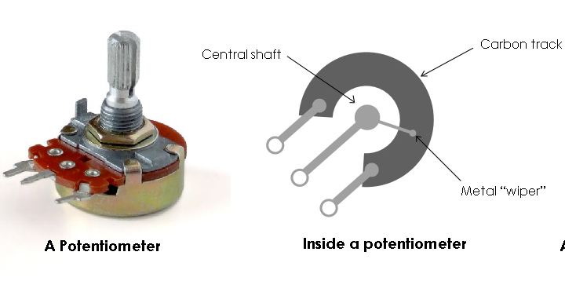

①

②

③

|  |  |
| --- | --- |
| **Pins 1-2** |  |
| **Pins 2-3** |  |
| **Pins 1-3** |  |

1. Describe the function and appropriate pin location for each servo wire.

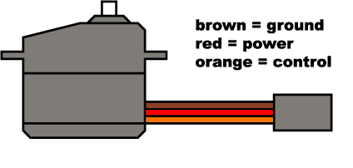

Brown/Black =

Yellow/Orange =

Red =

1. Describe the function for each label in the figure below. Write your answer next to the label.

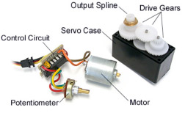

Mechanical Assembly of the Neu-Pulator

WORKSHEET #3

1. Name each of the following components:

|  |  |  |  |
| --- | --- | --- | --- |
| http://www.concretescrews.org/img/flat-head-self-tapping%20screw.jpg | http://vignette2.wikia.nocookie.net/tlaststand/images/a/a2/Bolt_nut.jpg/revision/latest?cb=20150113235801 | https://www.belmetric.com/images/AML14SS.jpg | http://www.reliablehardware.com/images/products/detail/Washers2.jpg |
| *__________________* | *__________________* | *__________________* | *__________________* |

1. Characterize the following bolt/screw using the standard notation:

|  |  |
| --- | --- |
| http://www.copyandwaste.com/media/uploads/measuring_metric_bolts.jpg  **0.5** | *__________________* |

1. Name each of the head types

|  |  |  |
| --- | --- | --- |
| https://jaysteeleblog.files.wordpress.com/2013/03/34-phillips.jpg | http://media.midwayusa.com/productimages/880x660/Primary/380/380324.jpg | http://www.robotmesh.com/media/catalog/product/cache/1/image/1280x/040ec09b1e35df139433887a97daa66f/s/p/spare_competition_field_hardware_3.jpg |
| *__________________* | *__________________* | *__________________* |

Sensing Human Motion

WORKSHEET #4

1. Describe what the EMG sensor measures and its three processing steps.
2. Measure the muscle activation level, in volts, for relaxed and contracted muscles:

|  |  |  |
| --- | --- | --- |
|  | **Relaxed** | **Contracted** |
| **Biceps** |  |  |
| **Forearm** |  |  |

1. Draw a diagram of the Neu-Pulator electrical circuit:

|  |
| --- |
|  |

Robotic Arm Reaching Challenge

WORKSHEET #5

Scores:

|  |  |  |
| --- | --- | --- |
| Try 1 | Try 2 | Try 3 |